Q1. Concept Map: DBMS, Schema, Instance, Data Model, ER Diagram, Entity, Attribute, Relationship
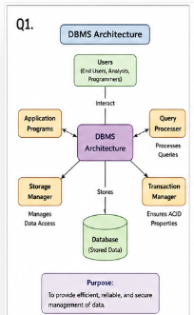

Q2.Create a concept map for the three-level ANSI/SPARC architecture showing data independence at each level.

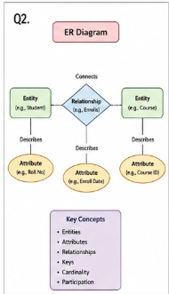

Q3.Map the relationship between file-based systems and database systems, highlighting the problems solved by DBMS.

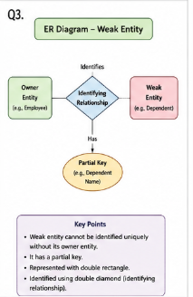

Q4.Design a concept map for ER diagram components: Entity, Weak Entity, Attribute Types, Relationship Types, and Participation Constraints.
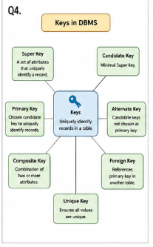

Q5.Construct a concept map comparing Hierarchical, Network, and Relational data models with their key properties.

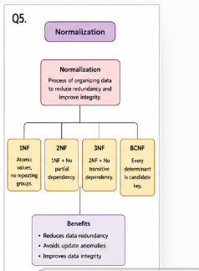

Q6.Develop a concept map for the EER model showing how it extends the basic ER model with Generalization, Specialization, and Aggregation.

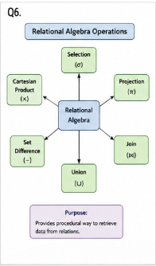

Q7.Create a visual concept map for the DBMS software architecture, illustrating the flow from user request to data retrieval.

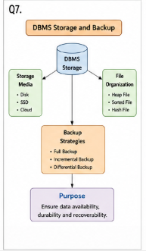

Q8.
Map the data models discussed in CO1 to real-world applications and explain the suitability of each model.

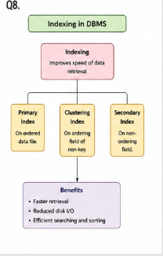

Q9.Construct a concept map for Schemas and Instances, showing how they relate to Physical and Logical Data Independence.

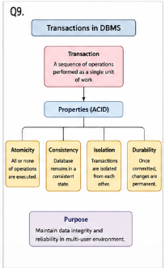

Q10.Design a concept map for the roles and responsibilities in a DBMS environment: DBA, End User, and Application Developer.

